September 5th, 2018
Clark Families,
The library is excited to announce the return of “The Pumpkin Book Character Project!” Your student is invited to decorate a pumpkin like a favorite book character and have it displayed in the library!
If you would like to participate, please complete the pumpkin character information page and bring it to school along with your decorated pumpkin. Please feel free to help your student complete this page! If you also have the book, bring it to school to be displayed with your pumpkin. Please remember to write your name on everything!
Pumpkin Decorating Guidelines:
- Pumpkins must be plastic, or foam as they rot quickly inside and can make a real mess! (Michael’s, Lowes, and Home Depot sell them, often half-off in October)
- NO carved pumpkins please!
- Students must be able to carry their own pumpkin
- Please write the student’s name and teacher on the pumpkin, book, and book character page.
Pumpkins should be brought to the Clark library the morning of Monday, October 15th during student arrival (8:45am-9:15am).
Pumpkins and books will be sent home with students on Friday, October 26th.
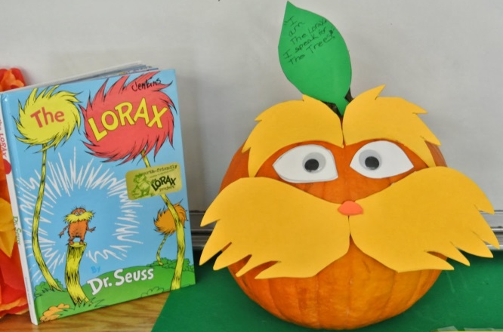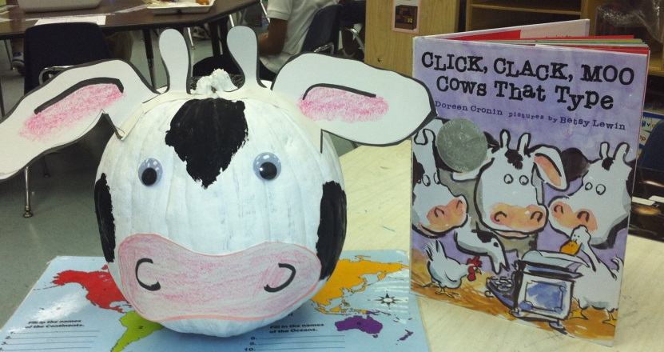
We are looking forward to seeing all of the creative book character pumpkins!
Sincerely, Clark Librarians,
Mrs. Guillen Miss. Anderson
guillent@issaquah.wednet.edu andersonM3@issaquah.wednet.edu
425-837-6285 Miss Hogan
hoganb@issaquah.wednet.edu

